Axis Privilege CC

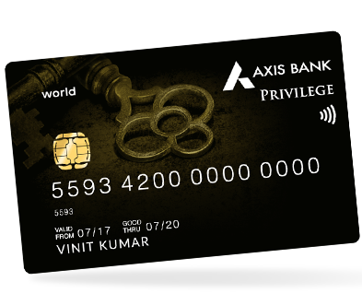

CARD BENEFITS  
1. Double the benefit upon achieving spends milestone of Rs. 2.5 lakhs by converting your Edge Reward points to Multi Brand vouchers worth twice the value. Detailed T&Cs at : <https://www.axisbank.com/docs/default-source/default-document-library/axis-privilege-credit-card-milestone-benefit-terms-and-conditions.pdf>

2. Annual fee of Rs. 1500 will be reversed on achieving spends of Rs. 2.5 lakhs in the previous card anniversary. Spend threshold excludes rent and wallet transactions.

3. 2 complimentary access to Airport lounges per calendar quarter to select domestic lounges with this card. Please check : <https://www.axisbank.com/docs/default-source/default-document-library/axis-bank-mastercard-airport-lounge-access_program.pdf> for detailed list.

4. Rs. 1000 off or more via Axis Bank Dining Delights program with EazyDiner. Click here: <https://www.axisbank.com/grab-deals/online-offers/offer-detail/dining-delights-axis-bank-exclusive-program-with-eazydiner> for details.

5. Fuel surcharge refund on spends at all fuel stations across India with this card. Valid on transactions between INR 400-INR 4000 only. Service tax charged on fuel surcharge is non-refundable. No reward points on fule transactions. Maximum benefit upto INR 400 per statement cycle. The fuel surcharge is not levied by the card issuing bank, on certain fuel transactions, the fuel surcharge may be levied as INR 10+GST instead of 1%+GST.

6. Earn AXIS EDGE REWARDS for transactions and 500+ rewards and offers to redeem points. Earn points for these transactions:

- 10 points on every Rs. 200 spent on the credit card domestically/internationally.

- Spends done on insurance, rent, fuel, educational services, utilities and government MCC (Merchant category codes) will not be eligible for earning EDGE REWARDS. To redeem points, check [AXIS EDGE REWARDS Catalog.](https://edgerewards.axisbank.co.in/lms/)

7. Purchase protection plan upto Rs. 1 lakh.

- Credit shield 1 lakh

- Loss Travel Documents Cover upto 300 USD

- Delay of Check-In baggage cover upto 300 USD

- Loss of Check-In baggage cover upto 500 USD.

Check T&Cs: <https://www.axisbank.com/docs/default-source/default-document-library/axis-bank-privilege-credit-card_insurance-t-c.pdf?sfvrsn=587b8255_12>

8. Get 12500 EDGE REWARDS Points redeemable against multi Brand vouchers worth Rs. 5000 upon levy of joining fees and on completion of 1st transaction within 30 days of card setup. For priority banking customers (no joining fees) , 6250 EDGE REWARD points redeemable against multi Brand vouchers worth Rs. 2500 on completion of 1st transaction within 30 days of card setup. For T&Cs, check: <https://www.axisbank.com/docs/default-source/default-document-library/axis-privilege-credit-card-activation-benefit-terms-and-conditions.pdf>

Fees and List of all Charges

* Joining Fees: Rs 1500 + GST (Nil for priority customers only)
* Annual Fees: Rs 1500 + GST
* Interest rate: 3.6% per month
* Cash Withdrawal charges: 2.5% or Rs 500, whichever is higher
* Card Replacement charges: Nil

How to Apply for Axis Privilege Credit Card

* User click on the CTA Button or tracking link
* User click Login/Join Now and do OTP verification
* He/she Select Axis Privilege Credit Card and provide the required details
* User’s application will be submitted, and a confirmation SMS will be sent on approval of user’s application
* User get his/her application status within 10 minutes

Documents required for the application

* ID Proof
* Address Proof
* Income Proof
* PAN Card
* Coloured Photographs

Eligibility Criteria

* Employment status: Salaried or self-employed
* Income: Rs 50,000 per month (Salaried)
* Rs 60,000 per month (self-employed)
* Required Age: 21-65 years
* Applicant should be resident of India